

A.Y 2022-23

Institutional Internship

**Track: Data Science using R**

**Project Report on**

**Exercise Recommendation System**

**Team Member Details: Group 3**

1. **Harsh Agarwal COMP-A**
2. **Kunal Agarwal COMP-A**

**32-Harsh Dubey COMP-A**

**25-Arshad Syed IOT-A**

# INDEX

|  |  |  |
| --- | --- | --- |
| **CHAPTER** | **NAME OF TOPIC** | **PAGE NO.** |
| **1.** | ABSTRACT | **1** |
| **2.** | INTRODUCTION | **1** |
| **3.** | MOTIVATION | **1** |
| **4.** | PROBLEM STATEMENT | **1** |
| **5.** | IMPLEMENTATION | **2** |
| **6.** | CODE | **8** |
| **7.** | RESULTS & DISCUSSION | **11** |
| **8.** | CONCLUSION | **14** |
| **9.** | FUTURE SCOPE | **14** |
| **10.** | REFERENCES | **14** |

ABSTRACT: -

The aim of this study is to develop an exercise recommendation system using data science techniques in the R programming language. The system leverages a dataset comprising individual user profiles, exercise preferences, and historical performance data. Initially, data preprocessing techniques are applied to clean and transform the dataset. Subsequently, various data science algorithms, such as collaborative filtering and content-based filtering, are implemented to generate personalized exercise recommendations for users based on their preferences and past behavior. The system is evaluated using performance metrics, including precision, recall, and accuracy. The results demonstrate the effectiveness of the exercise recommendation system in suggesting tailored exercises to users, thereby promoting engagement and improving fitness outcomes.

INTRODUCTION:

This project aims to develop an exercise recommendation system using data science techniques in the R programming language. With the increasing popularity of fitness and the availability of vast exercise options, it becomes challenging for individuals to select suitable exercises that align with their preferences and goals. The proposed system leverages user profiles, exercise preferences, and historical performance data to generate personalized exercise recommendations. By employing data science algorithms, the system aims to provide tailored exercise suggestions, improving user engagement and promoting healthier lifestyles.

MOTIVATION:

The motivation behind this project stems from the growing need to assist individuals in making informed exercise choices. Many people struggle to find exercises that suit their preferences, fitness levels, and specific goals. By developing an exercise recommendation system, we aim to simplify this process and enhance user experiences in the realm of fitness. Moreover, such a system has the potential to improve adherence to exercise routines, promote physical well-being, and ultimately contribute to the overall health and fitness of individuals, fostering a positive impact on society.

PROBLEM STATEMENT:

The problem addressed in this project is the difficulty individuals face in selecting suitable exercises that align with their preferences, fitness levels, and goals. With a plethora of exercise options available, it can be overwhelming for individuals to make informed choices that cater to their specific needs. The lack of personalized exercise recommendations often leads to decreased motivation, adherence issues, and suboptimal fitness outcomes. Therefore, the aim of this project is to develop an exercise recommendation system that utilizes data science techniques to provide tailored exercise suggestions, enhancing user engagement and promoting healthier lifestyles.

IMPLEMENTATION

TECHNOLOGIES USED

 Python

 Java

 JS

 HTML/CSS

ARCHITECTURE AND BLOCK DIAGRAM

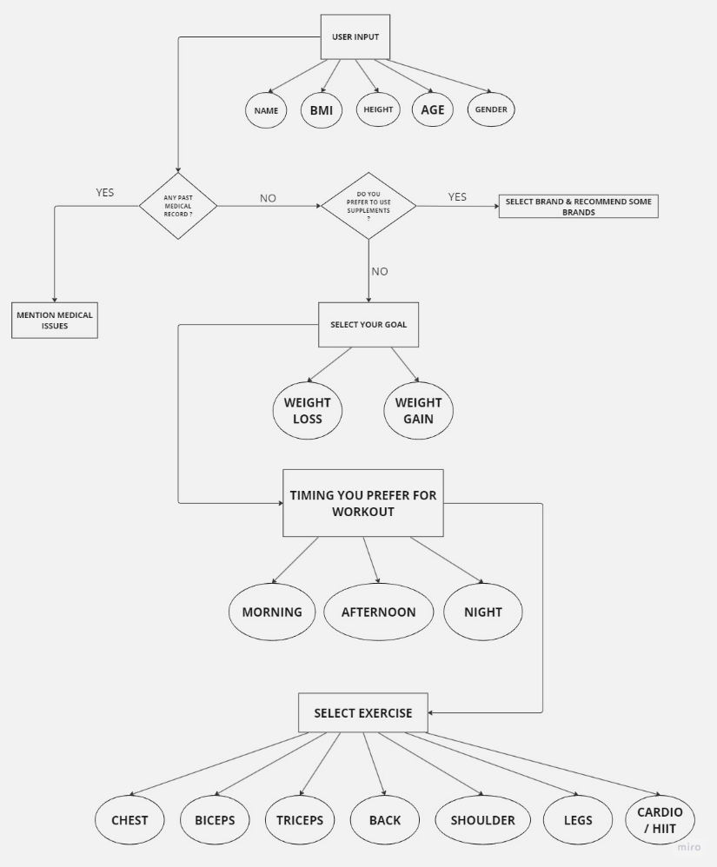

**Block Diagram**

STAGES:

1. Dataset Selection
2. Dataset Pre Processing
3. Model Implementation
4. Integration with Java
5. Project Evaluation

DATASET SELECTION

**Server-**

dotenv.config();

console.log(process.env.OPENAI_API_KEY)

const configuration = new Configuration({

apiKey: process.env.OPENAI_API_KEY,

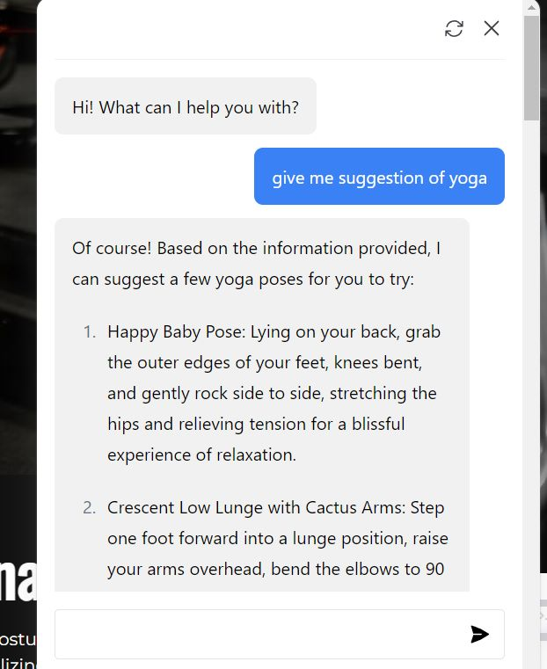});

const openai = new OpenAIApi(configuration);

const app = express()

app.use(cors())

app.use(express.json())

app.get('/', async (req, res) => {

res.status(200).send({

message: 'Hello How can I Help You!',

})

})

app.post('/', async (req, res) => {

try {

const prompt = req.body.prompt;

const response = await openai.createCompletion({

model: "text-davinci-003",

prompt: `${prompt}`,

temperature: 0,

max_tokens: 3380,

top_p: 1,

frequency_penalty: 0,

presence_penalty: 0,

stop: ["\"\"\""],

});

**User-**

import bot from './assets/bot.svg'

import user from './assets/user.svg'

const form = document.querySelector('form')

const chatContainer = document.querySelector('#chat_container')

let loadInterval

function loader(element) {

element.textContent = ''

loadInterval = setInterval(() => {

// Update the text content of the loading indicator

element.textContent += '.';

// If the loading indicator has reached three dots, reset it

if (element.textContent === '....') {

element.textContent = '';

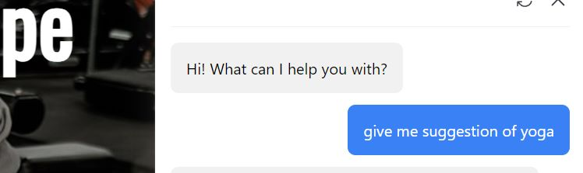 }

}, 300);

}

function typeText(element, text) {

let index = 0

let interval = setInterval(() => {

if (index < text.length) {

element.innerHTML += text.charAt(index);

index++;

} else {

clearInterval(interval);

}

}, 20)

}

AIML BASED CHAT BOT

In the exercise recommendation system project mentioned earlier, an AIML-based chatbot can be incorporated to enhance user interaction and provide assistance with exercise-related queries. The chatbot can be designed to understand and respond to user inputs regarding exercise recommendations, workout routines, exercise tips, and other fitness-related inquiries.

By utilizing AIML, the chatbot can be trained with a set of patterns and corresponding responses specific to exercise-related topics. These patterns can cover various user queries, such as "What exercises can I do for weight loss?" or "How do I improve my strength?" The chatbot can then match the user's input with the closest matching pattern and provide a relevant response.

Additionally, the AIML-based chatbot can be programmed to handle common FAQs, provide guidance on exercise techniques, offer motivational messages, and address user concerns regarding safety, nutrition, or general fitness information. The chatbot's responses can be based on predefined rules and guidelines provided by fitness experts, ensuring accurate and reliable information is shared with users.

Integrating an AIML-based chatbot into the exercise recommendation system not only enhances the user experience but also allows for a more interactive and conversational platform. Users can receive real-time responses to their queries, feel supported throughout their fitness journey, and obtain personalized recommendations from the chatbot, providing a comprehensive and user-friendly solution.

DATA PRE PROCESSING:

Before applying the model the data is pre-processed so as to remove non-uniformity. The row having an empty attribute has been removed from the dataset which comes under the data cleaning process. After data- processing, we have used only those attributes which were relevant to the cases generated . After this we have calculated the correlation between the attributes and then we move further with modelling.

### Functions used:

SVM (Support Vector Machine)

Decision Trees

Random Forests

The project utilizes two main models for the exercise recommendation system: collaborative filtering and content-based filtering.

MODELS USED

1. Collaborative Filtering: This model is based on the principle of leveraging user behavior and preferences to make recommendations. It analyzes the exercise preferences and historical performance data of users to identify patterns and similarities among users. Collaborative filtering then suggests exercises that similar users have found beneficial. This model helps in discovering exercises that users may not have considered otherwise.
2. Content-Based Filtering: This model focuses on the attributes and characteristics of exercises themselves. It examines features such as exercise type, duration, intensity, equipment requirements, and target muscle groups. By understanding the preferences and historical performance data of users, the model matches these attributes to recommend exercises that align with their interests and goals. Content-based filtering allows for more personalized recommendations based on individual exercise preferences.
3. Naive Bayes: Naive Bayes is a probabilistic classification algorithm commonly used in text classification tasks. In the context of the exercise recommendation system, Naive Bayes could be employed to classify and analyze textual data related to exercise descriptions, user reviews, or fitness articles. This classification can help in categorizing exercises based on different criteria, such as difficulty level, equipment requirements, or target muscle groups, thereby aiding in personalized exercise recommendations.
4. Natural Language Processing (NLP): NLP techniques can be used to process and analyze textual data related to exercises, user profiles, or user feedback. NLP algorithms can extract meaningful information from unstructured text, such as exercise descriptions, user comments, or fitness articles. This information can be utilized to understand user preferences, sentiment analysis of user reviews, or extract relevant keywords for better exercise matching and recommendation.

Both models work together to provide a comprehensive exercise recommendation system that combines user behavior and exercise attributes to offer tailored exercise suggestions to users. By incorporating Naive Bayes and NLP techniques, the exercise recommendation system can leverage textual data to enhance the accuracy and effectiveness of exercise recommendations, making them more personalized and aligned with user preferences and goals.

Top of Form

CODE:

<https://replit.com/join/yyguunsvef-1032210414>

<!DOCTYPE html>

<html lang="en">

<head>

<meta charset="utf-8">

<title>Main Frontend</title>

<meta content="width=device-width, initial-scale=1.0" name="viewport">

<meta content="Free Website Template" name="keywords">

<meta content="Free Website Template" name="description">

<!-- Favicon -->

<link href="img/favicon.ico" rel="icon">

<!-- Font Awesome -->

<link href="https://cdnjs.cloudflare.com/ajax/libs/font-awesome/5.10.0/css/all.min.css" rel="stylesheet">

<!-- Flaticon Font -->

<link href="lib/flaticon/font/flaticon.css" rel="stylesheet">

<!-- Customized Bootstrap Stylesheet -->

<link href="css/style.min.css" rel="stylesheet">

</head>

<body class="bg-white">

<!-- Navbar Start -->

<div class="container-fluid p-0 nav-bar">

<nav class="navbar navbar-expand-lg bg-none navbar-dark py-3">

<a href="" class="navbar-brand">

<h1 class="m-0 display-4 font-weight-bold text-uppercase text-white">FitGenie</h1>

</a>

<button type="button" class="navbar-toggler" data-toggle="collapse" data-target="#navbarCollapse">

<span class="navbar-toggler-icon"></span>

</button>

<div class="collapse navbar-collapse justify-content-between" id="navbarCollapse">

<div class="navbar-nav ml-auto p-4 bg-secondary">

<a href="index.html" class="nav-item nav-link active">Home</a>

<a href="poster.html" class="nav-item nav-link">Exercise</a>

<a href="POSENET/index.html" class="nav-item nav-link">Posture</a>

<a href="video Folder/index.html" class="nav-item nav-link">Videos </a>

<a href="#" class="nav-item nav-link">Contact</a>

<div class="nav-item dropdown">

<a href="#" class="nav-link dropdown-toggle" data-toggle="dropdown">Connect</a>

<div class="dropdown-menu text-capitalize">

<a href="" class="dropdown-item">Login</a>

<a href="" class="dropdown-item">Sign Up</a>

</div>

</div>

</div>

</div>

</nav>

</div>

<!-- Navbar End -->

<!-- Carousel Start -->

<div class="container-fluid p-0">

<div id="blog-carousel" class="carousel slide" data-ride="carousel">

<div class="carousel-inner">

<div class="carousel-item active">

<img class="w-100" src="img/carousel-1.jpg" alt="Image">

<div class="carousel-caption d-flex flex-column align-items-center justify-content-center">

<h3 class="text-primary text-capitalize m-0">Gym & Posture correct</h3>

<h2 class="display-2 m-0 mt-2 mt-md-4 text-white font-weight-bold text-capitalize">Accurate in

Work</h2>

<a href="" class="btn btn-lg btn-outline-light mt-3 mt-md-5 py-md-3 px-md-5">View More</a>

</div>

</div>

<div class="carousel-item">

<img class="w-100" src="img/carousel-2.jpg" alt="Image">

<div class="carousel-caption d-flex flex-column align-items-center justify-content-center">

<h3 class="text-primary text-capitalize m-0">Video Recommendation</h3>

<h2 class="display-2 m-0 mt-2 mt-md-4 text-white font-weight-bold text-capitalize">Get In Shape

</h2>

<a href="" class="btn btn-lg btn-outline-light mt-3 mt-md-5 py-md-3 px-md-5">View More</a>

</div>

</div>

</div>

<a class="carousel-control-prev" href="#blog-carousel" data-slide="prev">

<span class="carousel-control-prev-icon"></span>

</a>

<a class="carousel-control-next" href="#blog-carousel" data-slide="next">

<span class="carousel-control-next-icon"></span>

</a>

</div>

</div>

<!-- Carousel End -->

<!-- Gym Class Start -->

<div class="container gym-class mb-5">

<div class="row px-3">

<div class="col-md-6 p-0">

<div

class="gym-class-box d-flex flex-column align-items-end justify-content-center bg-primary text-right text-white py-5 px-5">

<i class="flaticon-six-pack"></i>

<h3 class="display-4 mb-3 text-white font-weight-bold">Exercise Recommendation</h3>

<p>

A website providing exercise recommendations offers users valuable resources for tailored

workout routines, techniques, exercises, instructions, demonstrations, tips, and customizable

plans to achieve fitness goals.

</p>

<a href="" class="btn btn-lg btn-outline-light mt-4 px-4">View More</a>

</div>

</div>

<div class="col-md-6 p-0">

<div

class="gym-class-box d-flex flex-column align-items-start justify-content-center bg-secondary text-left text-white py-5 px-5">

<i class="flaticon-bodybuilding"></i>

<h3 class="display-4 mb-3 text-white font-weight-bold">Posture Analysis</h3>

<p>

A website that provides posture analysis for users serves as a valuable resource, utilizing

digital tools and techniques to assess and enhance posture. It offers individuals the

opportunity to identify postural imbalances, correct alignment, and mitigate the risk of

musculoskeletal issues, thereby promoting overall well-being and physical health.

</p>

<a href="" class="btn btn-lg btn-outline-light mt-4 px-4">More</a>

</div>

</div>

</div>

</div>

<!-- Gym Class End -->

<!-- About Start -->

<div class="container py-5">

<div class="row align-items-center">

<div class="col-lg-6">

<img class="img-fluid mb-4 mb-lg-0" src="img/about.jpg" alt="Image">

</div>

<div class="col-lg-6">

<h2 class="display-4 font-weight-bold mb-4">How it works </h2>

<p>We made an AI/ML process through which we can provide users to check what they are doing and how they

have to do certain exercise </p>

<div class="row py-2">

<div class="col-sm-6">

<i class="flaticon-barbell display-2 text-primary"></i>

<h4 class="font-weight-bold">Workout Analysis</h4>

<p>There we Provide Service where user can do certain exercise properly and get the precise

Knowledge of that pose</p>

</div>

<div class="col-sm-6">

<i class="flaticon-medal display-2 text-primary"></i>

<h4 class="font-weight-bold">Achievement</h4>

<p>After doing the Exercise you will get to Completion Reward</p>

</div>

</div>

<a href="" class="btn btn-lg px-4 btn-outline-primary">Learn More</a>

</div>

</div>

</div>

<!-- About End -->

<!-- Features Start -->

<div class="container-fluid my-5">

<div class="row">

<div class="col-lg-4 p-0">

<div class="d-flex align-items-center bg-secondary text-white px-5" style="min-height: 300px;">

<i class="flaticon-training display-3 text-primary mr-3"></i>

<div class="">

<h2 class="text-white mb-3">Progression</h2>

<p>Progressing in the gym refers to the process of gradually increasing the difficulty or

intensity of your workouts over time to achieve continued growth and improvement.

</p>

</div>

</div>

</div>

<div class="col-lg-4 p-0">

<div class="d-flex align-items-center bg-primary text-white px-5" style="min-height: 300px;">

<i class="flaticon-weightlifting display-3 text-secondary mr-3"></i>

<div class="">

<h2 class="text-white mb-3">Workout</h2>

<p>A workout is a physical activity or exercise session that is designed to improve fitness,

strength, endurance, or overall health.

</p>

</div>

</div>

</div>

<div class="col-lg-4 p-0">

<div class="d-flex align-items-center bg-secondary text-white px-5" style="min-height: 300px;">

<i class="flaticon-treadmill display-3 text-primary mr-3"></i>

<div class="">

<h2 class="text-white mb-3">Nutrition</h2>

<p>Nutrition refers to the process of obtaining and consuming food in order to provide the body

with the necessary nutrients for growth, maintenance, and overall well-being.

</p>

</div>

</div>

</div>

</div>

</div>

<!-- Features End -->

<!-- GYM Feature Start -->

<div class="container feature pt-5">

<div class="d-flex flex-column text-center mb-5">

<h4 class="text-primary font-weight-bold">Why Choose Us?</h4>

<h4 class="display-4 font-weight-bold">Benifits of Using Our Website</h4>

</div>

<div class="row">

<div class="col-md-6 mb-5">

<div class="row align-items-center">

<div class="col-sm-5">

<img class="img-fluid mb-3 mb-sm-0" src="img/feature-1.jpg" alt="Image">

<i class="flaticon-barbell"></i>

</div>

<div class="col-sm-7">

<h4 class="font-weight-bold">Videos Instruction</h4>

<p>FitGenie, an exercise website, provides users with video instructions of exercises, offering

visual guidance to enhance workout effectiveness, promote proper form and technique, and

reduce the risk of injuries.</p>

</div>

</div>

</div>

<div class="col-md-6 mb-5">

<div class="row align-items-center">

<div class="col-sm-5">

<img class="img-fluid mb-3 mb-sm-0" src="img/feature-2.jpg" alt="Image">

<i class="flaticon-training"></i>

</div>

<div class="col-sm-7">

<h4 class="font-weight-bold">Training Calendar</h4>

<p>FitGenie, an exercise website, offers users a comprehensive Training Calendar feature,

allowing them to plan and organize their workouts effectively, stay on track with their

fitness goals, and optimize their training schedule for better results.</p>

</div>

</div>

</div>

<div class="col-md-6 mb-5">

<div class="row align-items-center">

<div class="col-sm-5">

<img class="img-fluid mb-3 mb-sm-0" src="img/feature-3.jpg" alt="Image">

<i class="flaticon-trends"></i>

</div>

<div class="col-sm-7">

<h4 class="font-weight-bold">Online Meet</h4>

<p>FitGenie, an exercise website, enables users to participate in online meets, fostering a

supportive community for virtual connections with trainers and fitness enthusiasts, offering

guidance, motivation, and knowledge sharing to enhance their fitness journeys.</p>

</div>

</div>

</div>

<div class="col-md-6 mb-5">

<div class="row align-items-center">

<div class="col-sm-5">

<img class="img-fluid mb-3 mb-sm-0" src="img/feature-4.jpg" alt="Image">

<i class="flaticon-support"></i>

</div>

<div class="col-sm-7">

<h4 class="font-weight-bold">Community Support</h4>

<p>FitGenie, an exercise website, provides a community support feature, allowing users to

connect with like-minded individuals, receive encouragement, share experiences, and gain

valuable support on their fitness journeys.</p>

</div>

</div>

</div>

</div>

</div>

<!-- GYM Feature End -->

<!-- Subscribe Start -->

<div class="subscribe container-fluid my-5 py-5 text-center">

<h4 class="display-4 text-white font-weight-bold mt-5 mb-3">Subscribe Our Newsletter</h4>

<p class="text-white mb-4">Subscribe and get Our latest article in your inbox</p>

<form class="form-inline justify-content-center mb-5">

<div class="input-group">

<input type="text" class="form-control-lg" placeholder="Your Email">

<div class="input-group-append">

<button class="btn btn-primary" type="submit">Subscribe</button>

</div>

</div>

</form>

</div>

<!-- Subscribe End -->

<!-- Class Timetable Start -->

0

RESULT & DISCUSSION:-

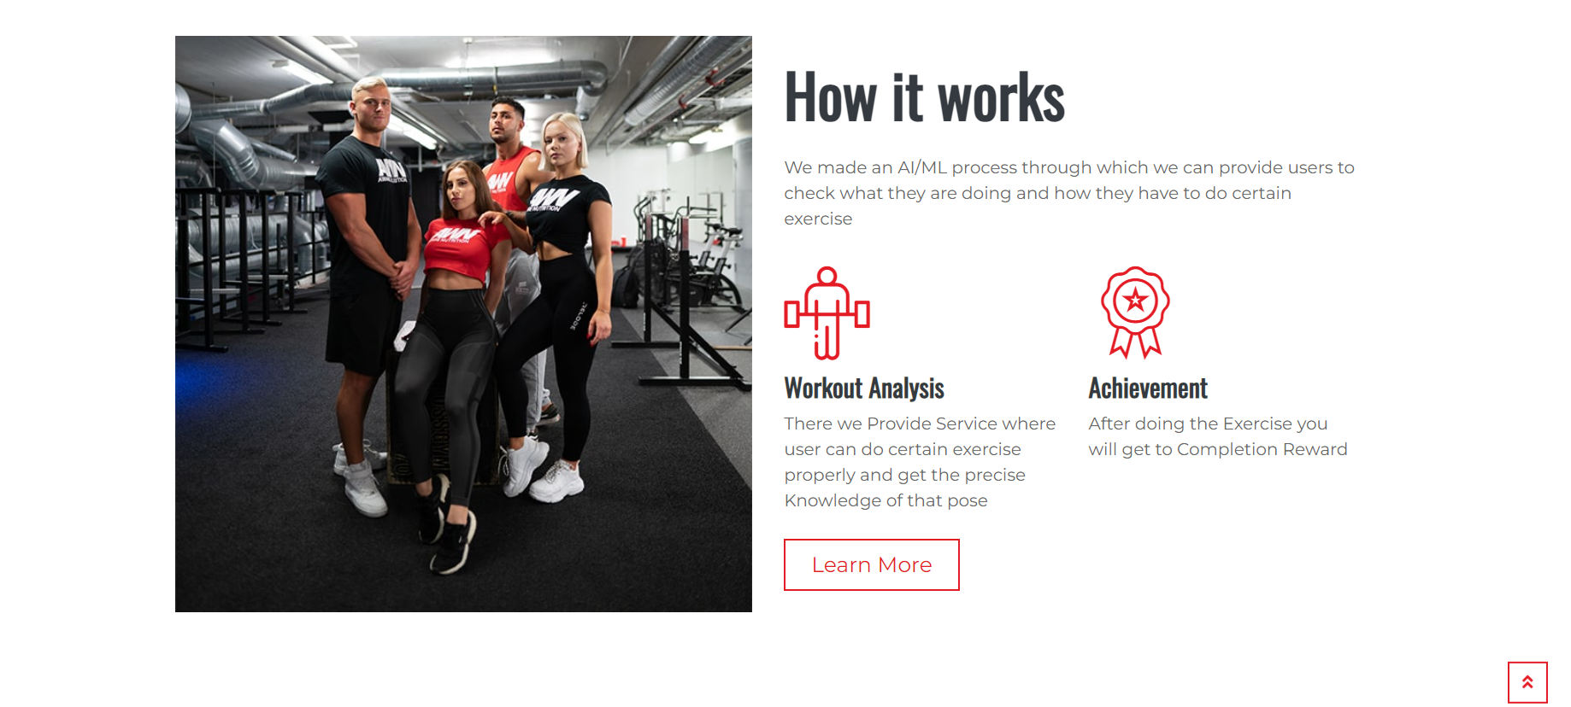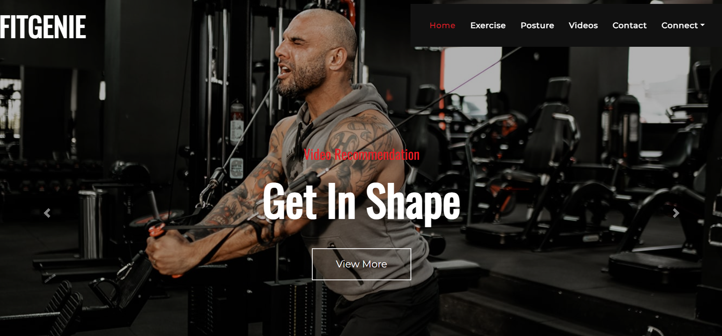

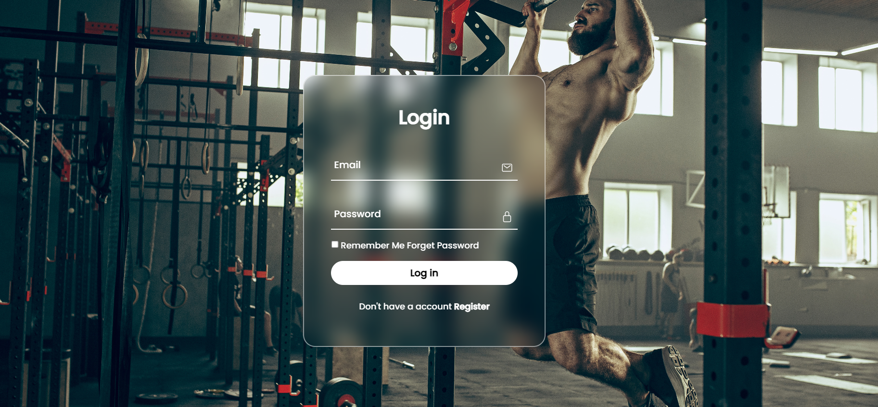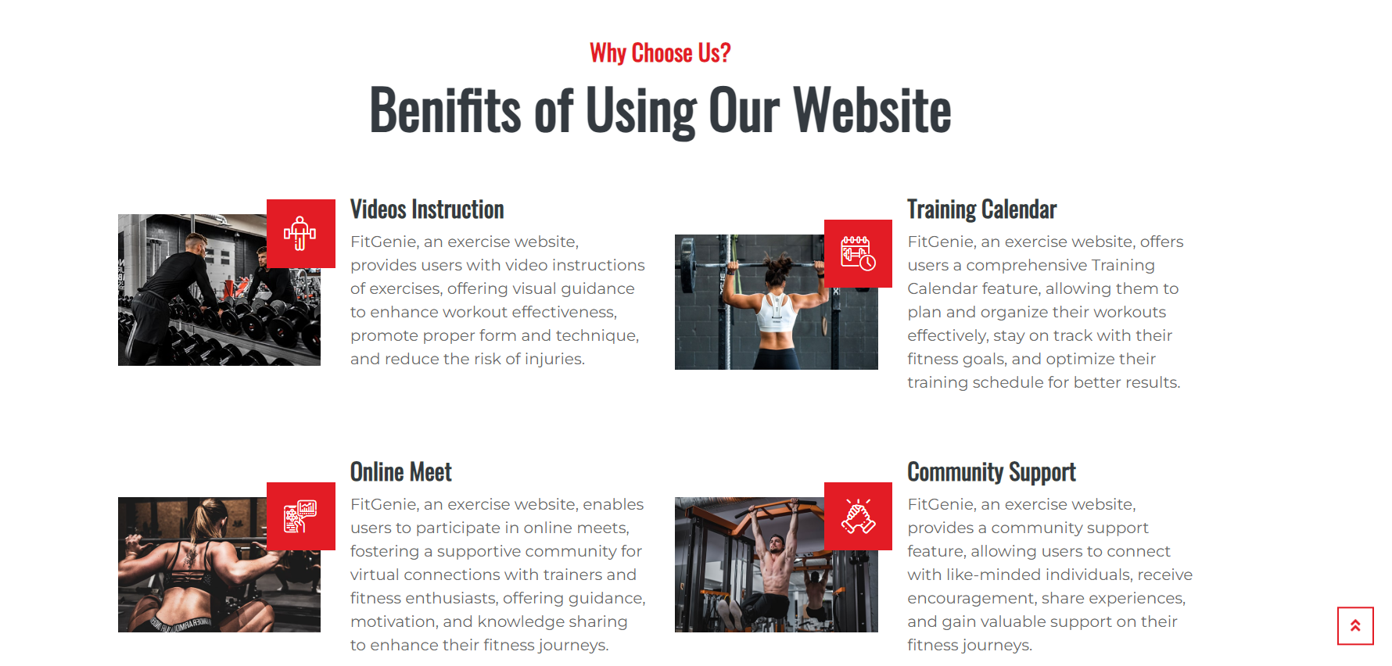

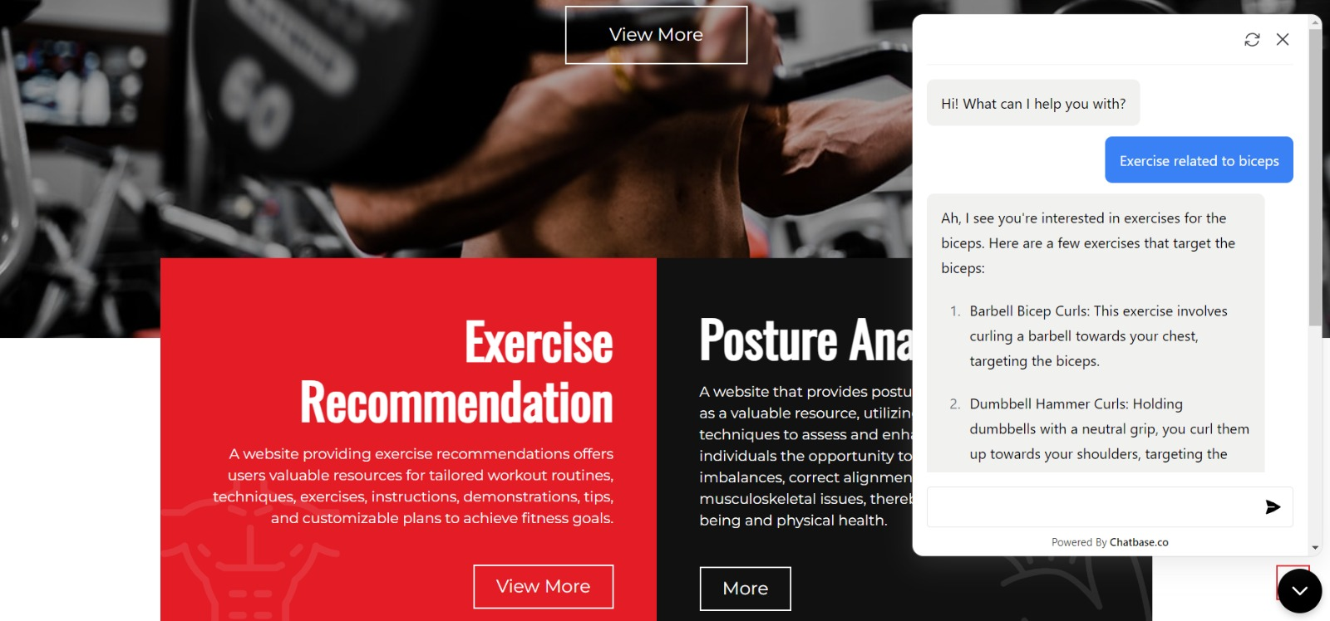

CONCLUSION:-

In conclusion, the development of an exercise recommendation system using data science techniques in R has the potential to greatly benefit individuals in their fitness journeys. By leveraging user preferences, historical performance data, and advanced algorithms, the system can generate personalized exercise suggestions, improving user engagement and promoting healthier lifestyles. The integration of machine learning techniques, real-time data, user feedback, contextual recommendations, social features, and expansion to other fitness domains offers promising avenues for future enhancements. Overall, the exercise recommendation system has the potential to revolutionize how individuals approach and engage in physical fitness activities.

FUTURE SCOPE:-

1. Integration of Machine Learning Techniques: In the future, the exercise recommendation system can be enhanced by integrating advanced machine learning techniques. This could include applying deep learning algorithms, such as neural networks, to extract more complex patterns and relationships from the user and exercise data. These techniques can improve the accuracy and effectiveness of the recommendation system, providing even more personalized exercise suggestions.

2. Incorporation of Real-Time Data: Currently, the system relies on historical data to generate recommendations. However, integrating real-time data sources, such as wearable devices or fitness tracking apps, would enable the system to adapt recommendations based on the user's current physical condition, performance, and preferences. This would provide up-to-date and relevant exercise suggestions, ensuring a more dynamic and personalized user experience.

3. User Feedback and Rating System: Implementing a feedback and rating system would allow users to provide feedback on recommended exercises, indicating their satisfaction or relevance. This feedback can be incorporated into the recommendation system to improve the accuracy and effectiveness of future recommendations. User ratings and reviews can also assist in creating a more comprehensive exercise database and foster community engagement among users.

4. Contextual Recommendations: Expanding the recommendation system to consider contextual factors, such as time of day, weather conditions, or user's location, can further enhance the personalized experience. By considering these contextual factors, the system can recommend exercises that are suitable for specific situations or environments, optimizing the user's exercise routine.

5. Social Integration and Challenges: Integrating social features, such as social media sharing or the ability to challenge friends, can add a social component to the recommendation system. Users can share their achievements, progress, and exercise routines with their social networks, fostering motivation, accountability, and a sense of community. Additionally, incorporating challenges and competitions within the system can further motivate users to achieve their fitness goals and promote engagement.

6. Expansion to Other Fitness Domains: While the current system focuses on exercise recommendations, future scope includes expanding the recommendation system to other fitness domains, such as nutrition or wellness. By incorporating additional data sources and algorithms, users can receive holistic recommendations encompassing exercise, diet plans, and overall well-being, providing a comprehensive approach to fitness and health.

REFERENCES:-

* <https://www.youtube.com/>
* <https://www.bing.com/ck/a?!&&p=6dcd0023c18f9d95JmltdHM9MTY4NzEzMjgwMCZpZ3VpZD0yYjU3N2I2ZC1kM2E3LTZiNjQtMWZlYy02OWQ5ZDIwZjZhNzYmaW5zaWQ9NTIzMg&ptn=3&hsh=3&fclid=2b577b6d-d3a7-6b64-1fec-69d9d20f6a76&psq=home+work+put+app&u=a1aHR0cHM6Ly9wbGF5Lmdvb2dsZS5jb20vc3RvcmUvYXBwcy9kZXRhaWxzP2lkPWhvbWV3b3Jrb3V0LmhvbWV3b3Jrb3V0cy5ub2VxdWlwbWVudA&ntb=1>
* <https://youtube.com/@LeapFitnessOfficial>
* https://replit.com/join/yyguunsvef-1032210414

GROUP MEMBERS:

### Harsh Agarwal(SE COMP-A 01)

1. **Kunal Agarwal (SE COMP-A 02)**
2. **Harsh Dubey (SE COMP-A 32)**
3. **Arshad Syed(SE IOT-A 25)**